***Assignment – 12***

**Using the operators IN, ANY, and ALL.**

1) Write a query that selects all customers whose ratings are equal to or greater than ANY of Serres’. 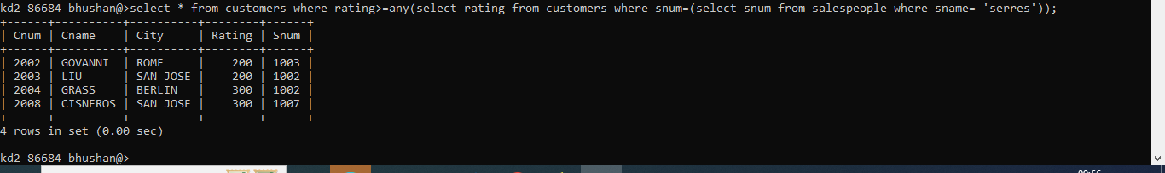

2) Write a query using ANY or ALL that will find all salespeople who have no customers located in their city. 

3) Write a query that selects all orders for amounts greater than any for the customers in London. 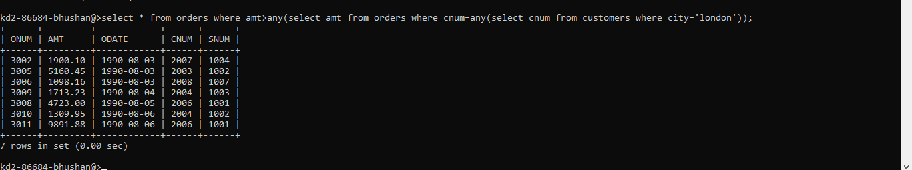

4) Write the above query using MIN or MAX.

